FBI FINGERPRINT CLEARANCE

Effective November 28, 2017 the PDE has changed vendors for FBI fingerprint clearance processing from Cogent to IDEMIA.

<https://uenroll.identogo.com/>

Cost is $22.60

Registration is required in order to have fingerprints taken.

1. Go to IDEMIA’s website:

<https://uenroll.identogo.com/>

1. Enter Service Code “1KG6XN”
2. Press Continue
3. Select Schedule or Manager Appointment
4. Enter Name, Birthdate, Email and Phone number

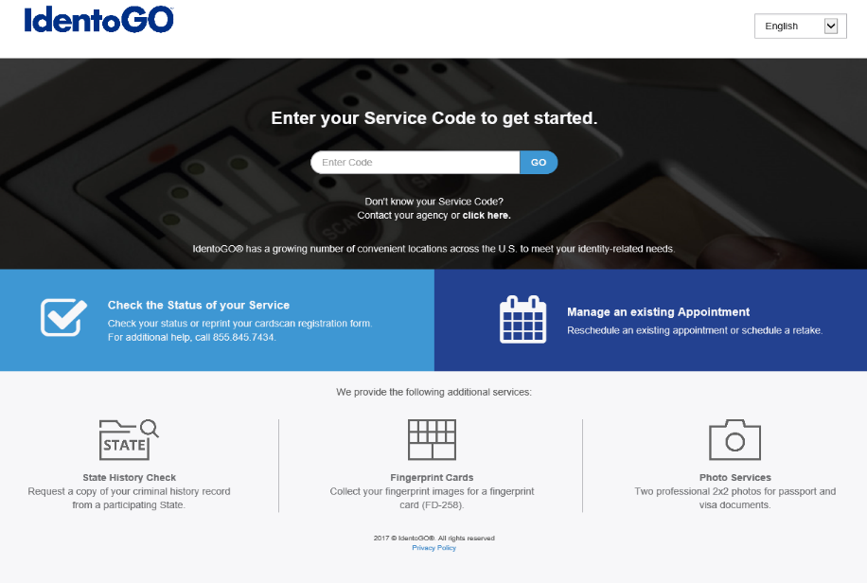

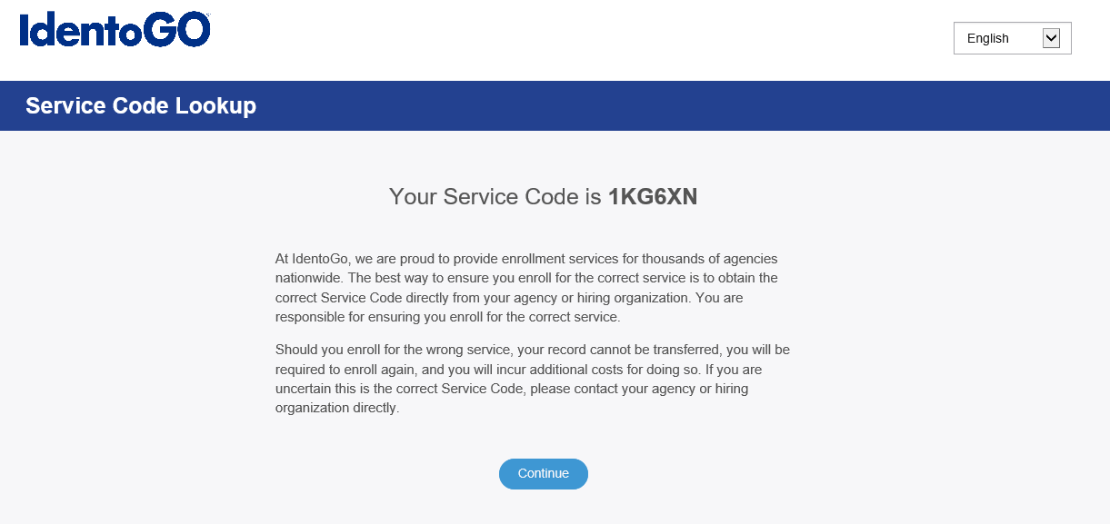

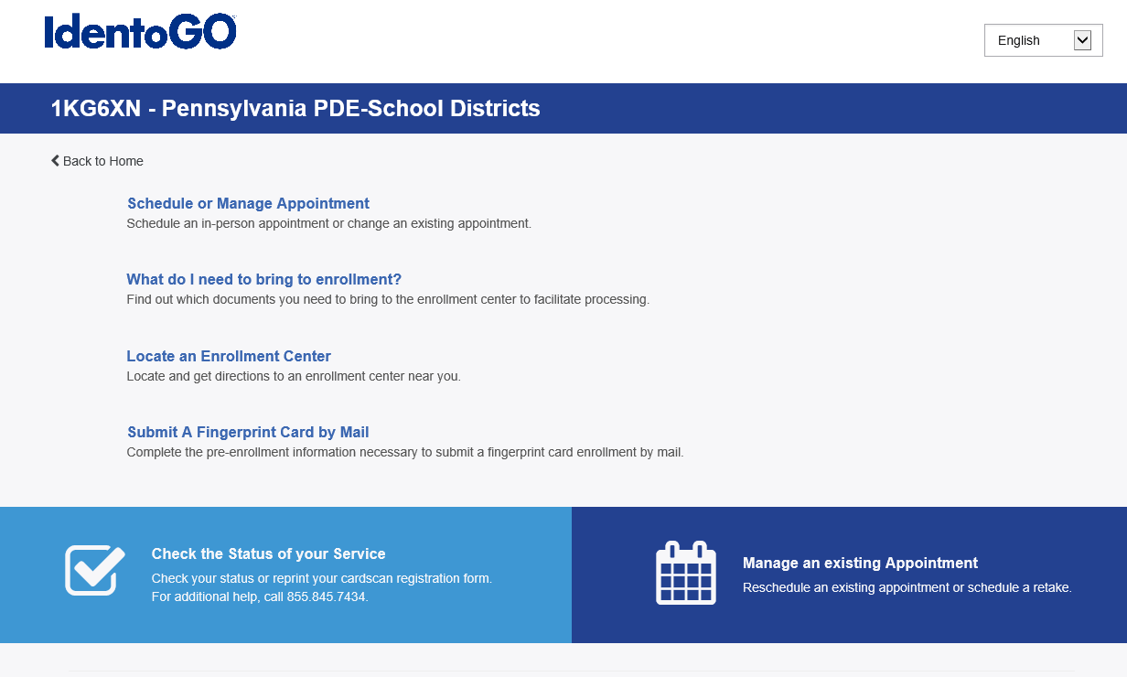

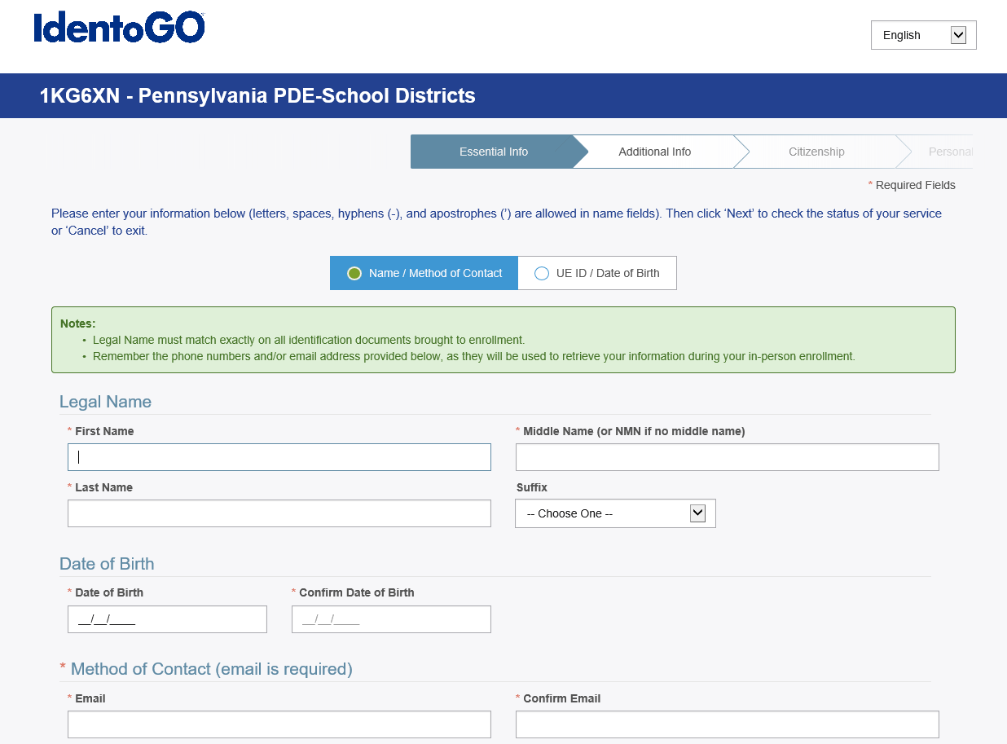

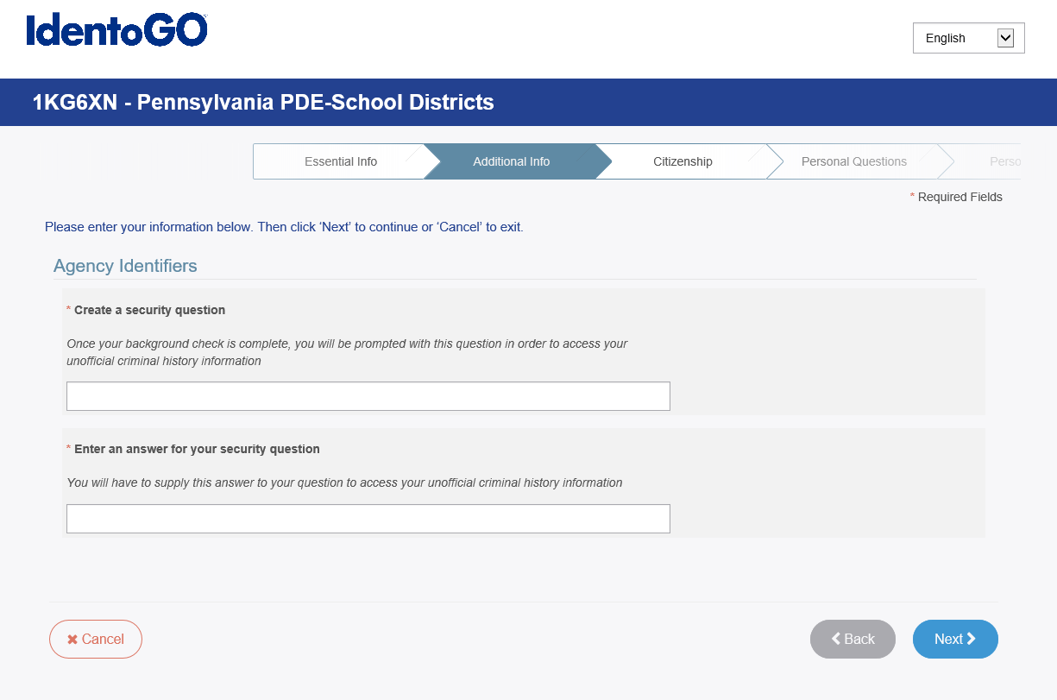

FBI FINGERPRINT CLEARANCE CONT.

1. Create a Security Question and Answer (notate for future reference)
2. Enter Citizenship Information
3. Enter answers to Personal Questions
4. Enter Personal Information

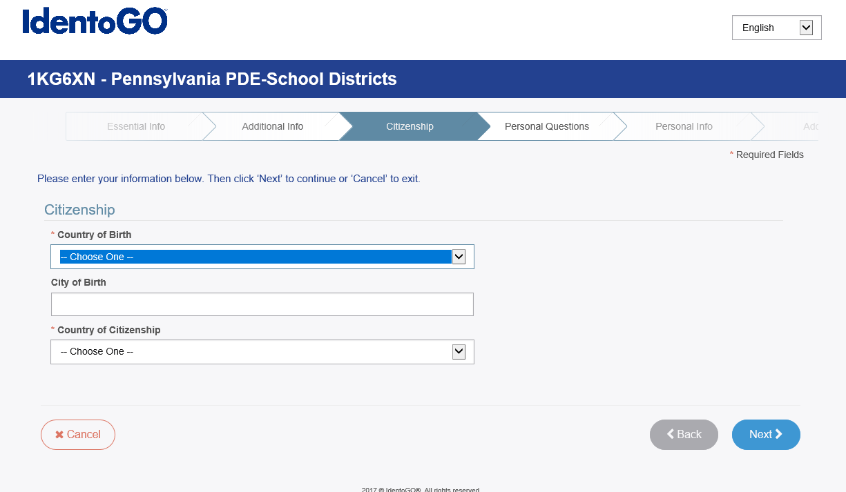

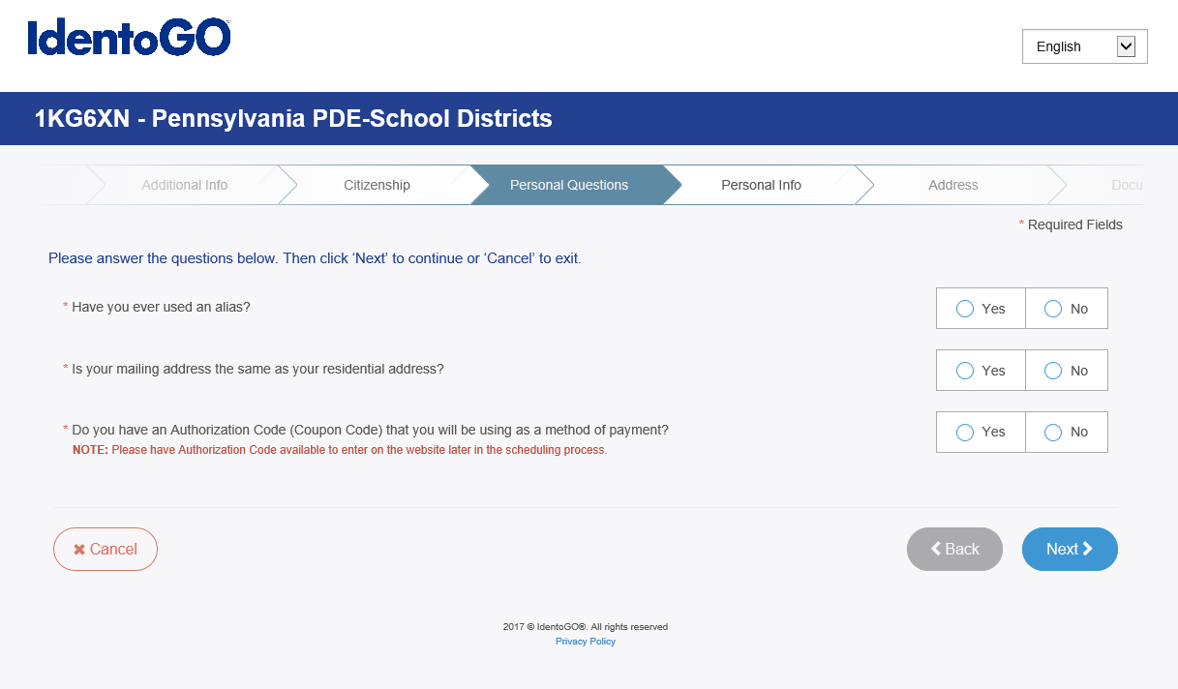

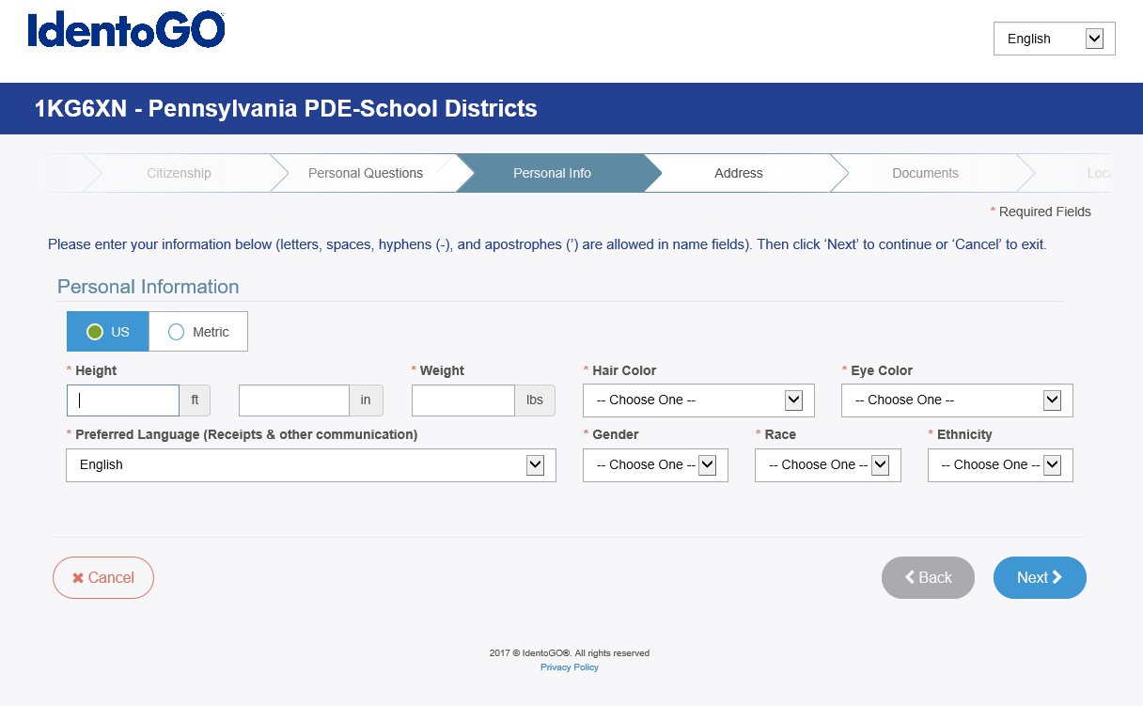

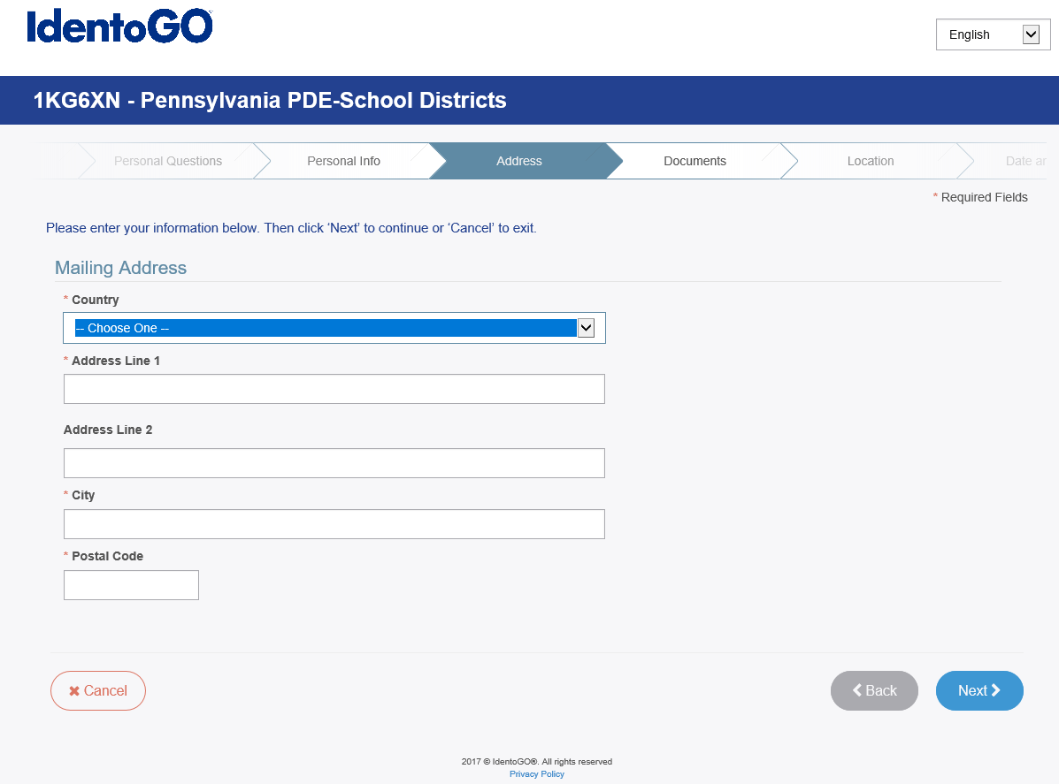

FBI FINGERPRINT CLEARANCE CONT.

10. Enter Address

1. Choose Document that you will bring with you for ID
2. Select Location
3. Schedule Appointment
4. Submit Registration
5. Print Confirmation
6. Payment is processed when prints are taken
7. Provide UEID to employer once prints have been processed

